質問力を上げて，言葉のキャッチボールを楽しもう

Let’s talk about !
the weekend

When ...?
時をたずねる
□ When did you get there?
□ When’s the tournament?

Where ...?
場所をたずねる
□ Where did you go?
□ Where do you want to go next?

Who ...?
「誰か」をたずねる
□ Who did you go with?
□ Who did you see?
What ...?
「何か」をたずねる
□ What did you do [eat / watch]?
□ What did you like about the movie?

Why ...?
理由をたずねる
□ Why did you go there?
□ Why not?

How ...?
様子・方法をたずねる
□ How did you get there?
□ How long did you stay there?

【その他の質問】
□ Did you like it?
□ Whose idea was it?

【やり取りの例】
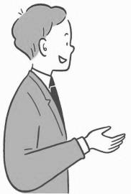
TIPS
次の語彙を参考に，相手の言葉に積極的に反応して会話を盛り上げよう。
cool, fun, awesome, great, amazing, too bad, terrible,
tough/rough, a shame
How was your weekend?
It was great! I ....
That sounds fun! What ...?

